**THE ANTI-DRIFT LAB**

**A WORKSHOP WITH ISA VENTO *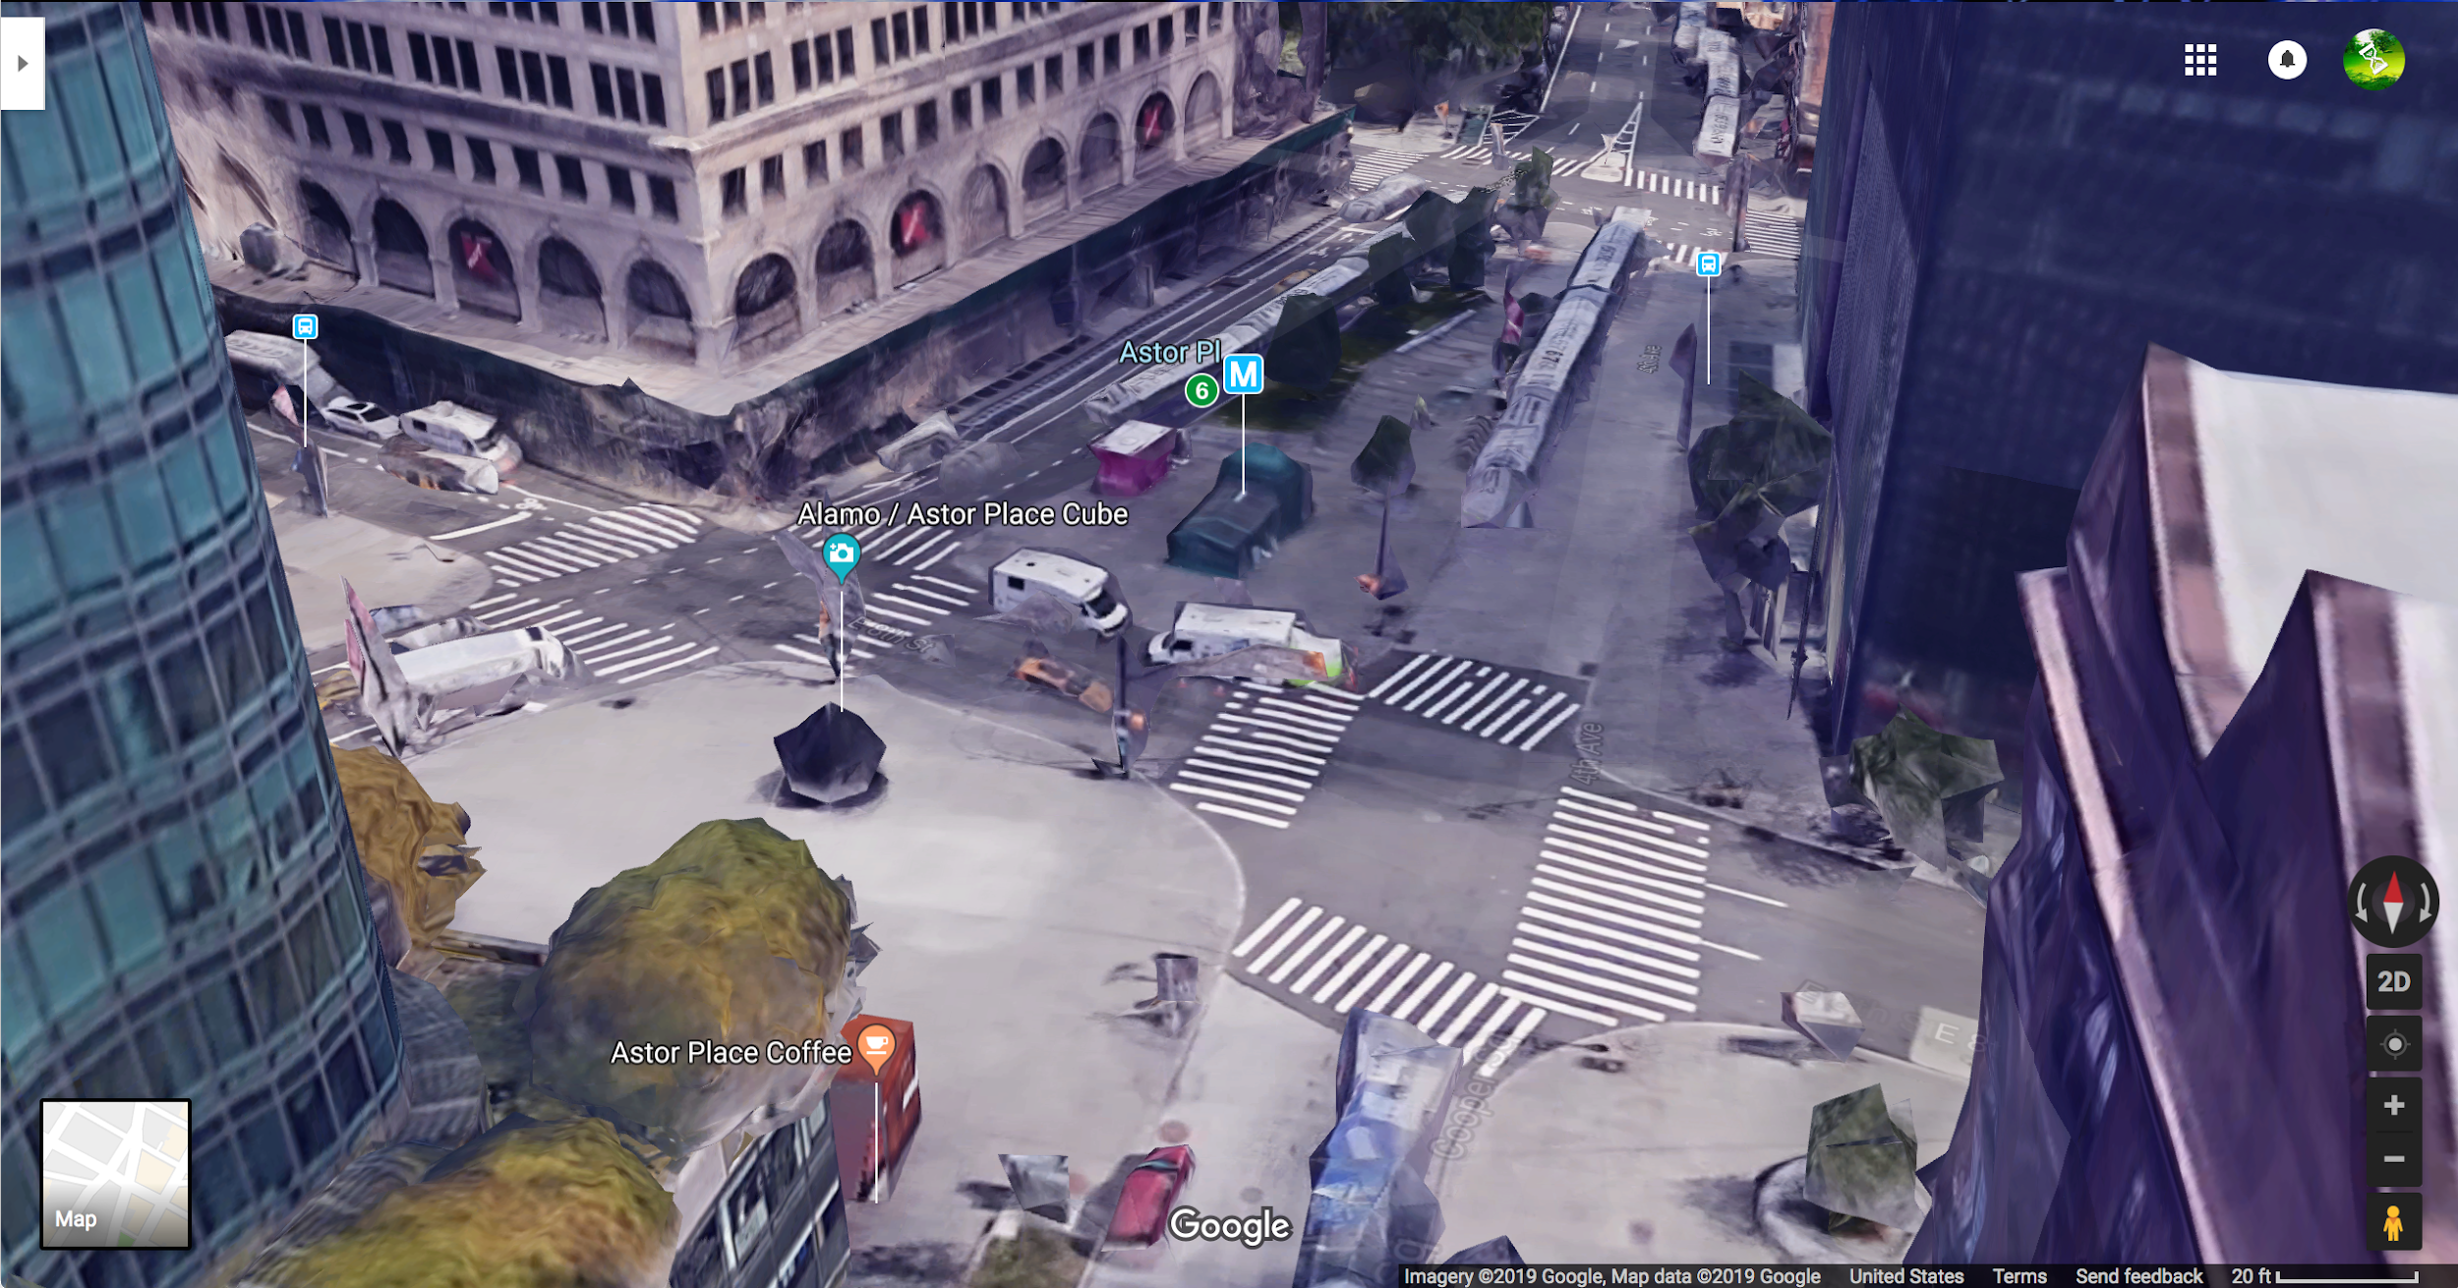***

**INFRASTRUCTURE**

**noun**

**"the physical components of interrelated systems providing** [**commodities**](https://en.wikipedia.org/wiki/Commodity) **and services essential to enable, sustain, or enhance societal** [**living conditions**](https://en.wikipedia.org/wiki/Quality_of_life)**".**[**[3]**](https://en.wikipedia.org/wiki/Infrastructure#cite_note-3)

**ASSEMBLAGE**

**noun**

**“A collection or gathering of things or people.” or “The action of gathering or fitting things together.”**

This workshop is an experiment of collective deceleration. Participants will engage in (and embody) a process of conscientious and slow data collection, processing, and documenting of a slice of urban space. Following our individual encounters with this zone, we will come together to interpret, dissect and re-assemble our subjectivities. Through guided discussion and a mapping exercise we will broaden their understanding of Manhattan’s ecosystem and the networks that sustain it.

In the light of current times, becoming deeply acquainted, slowly, with the interactions between material things, non-human species and humans that occupy and the city schema is a form of resistance towards the command of our navigation and co-existence. In turn, it allows us to formulate more informed agendas for our contribution to an equitable and resilient urban community.

Registered participants will be sent a field guide, and will carry out a visit to a site (that will require at least 30 minutes of their time & care) prior to our meeting at the library.

*Objective*:  
  
Participants of the workshop are invited to be both learners and teachers of the situation. This is largely a guided experiment that involves attempting to identify the edges and nodes that make up the network of an urban location.

They will gain some tools for quick and dirty field research and take part in a discussion about the nature and emergence of this space. This will be done through the creation of a map of relations between their found elements; an abstracted data visualisation or assemblage of temporary connections.

**PRE-WORKSHOP:**

You will receive a pdf two days before the workshop @ Bobst library, March 2nd. This is a document that will prompt you to visit an urban space, spend time there and to choose an object, thing, or critter in this perimeter; an element. It is to be physically documented a (this could be a photograph, a drawing, a screenshot of found element on google earth, a transcribed conversation, an object from the space) & brought to our meeting. *Remember/record where it is in the space.*

[*Link to the field guide*](https://docs.google.com/document/d/1q8DMZoHO9xN2AunBcDCer_Xg4B_m136rEu8Xnzz5DuY/edit)

**WORKSHOP/MEETING:**

*Part I :*Post-drift reflections & intro to *The Map of the Encounter of the Encounters  
(15 minutes)*

**Easing into the classroom**:

→ How did your ‘drift’ or walk feel? Did you uncover things you hadn’t before? Does this place mean something else to you now? What kind of details stood out to you most?

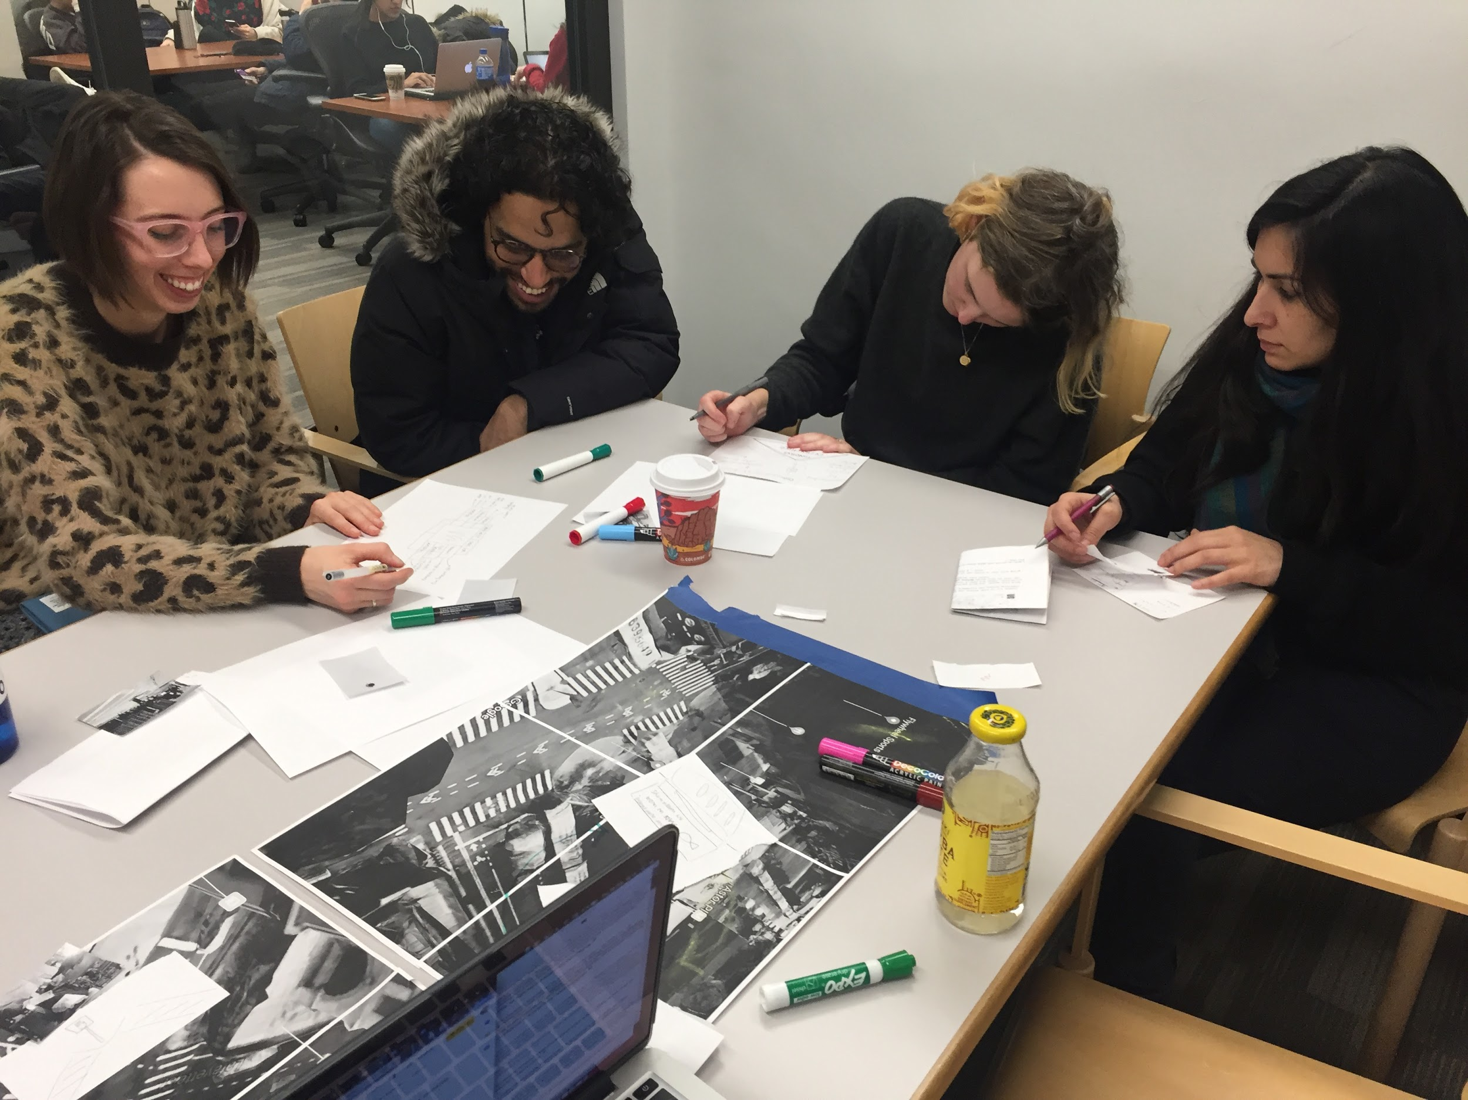

**Introduction to the Map & to Maintenance/Care table :**

→ Presentation of the map of Astor place & two elements already found

→ Why are our findings encounters? How is an encounter different to

→ The small table of maintenance/care

What/Who maintains or cares for your element & who/what is it maintained or cared by?

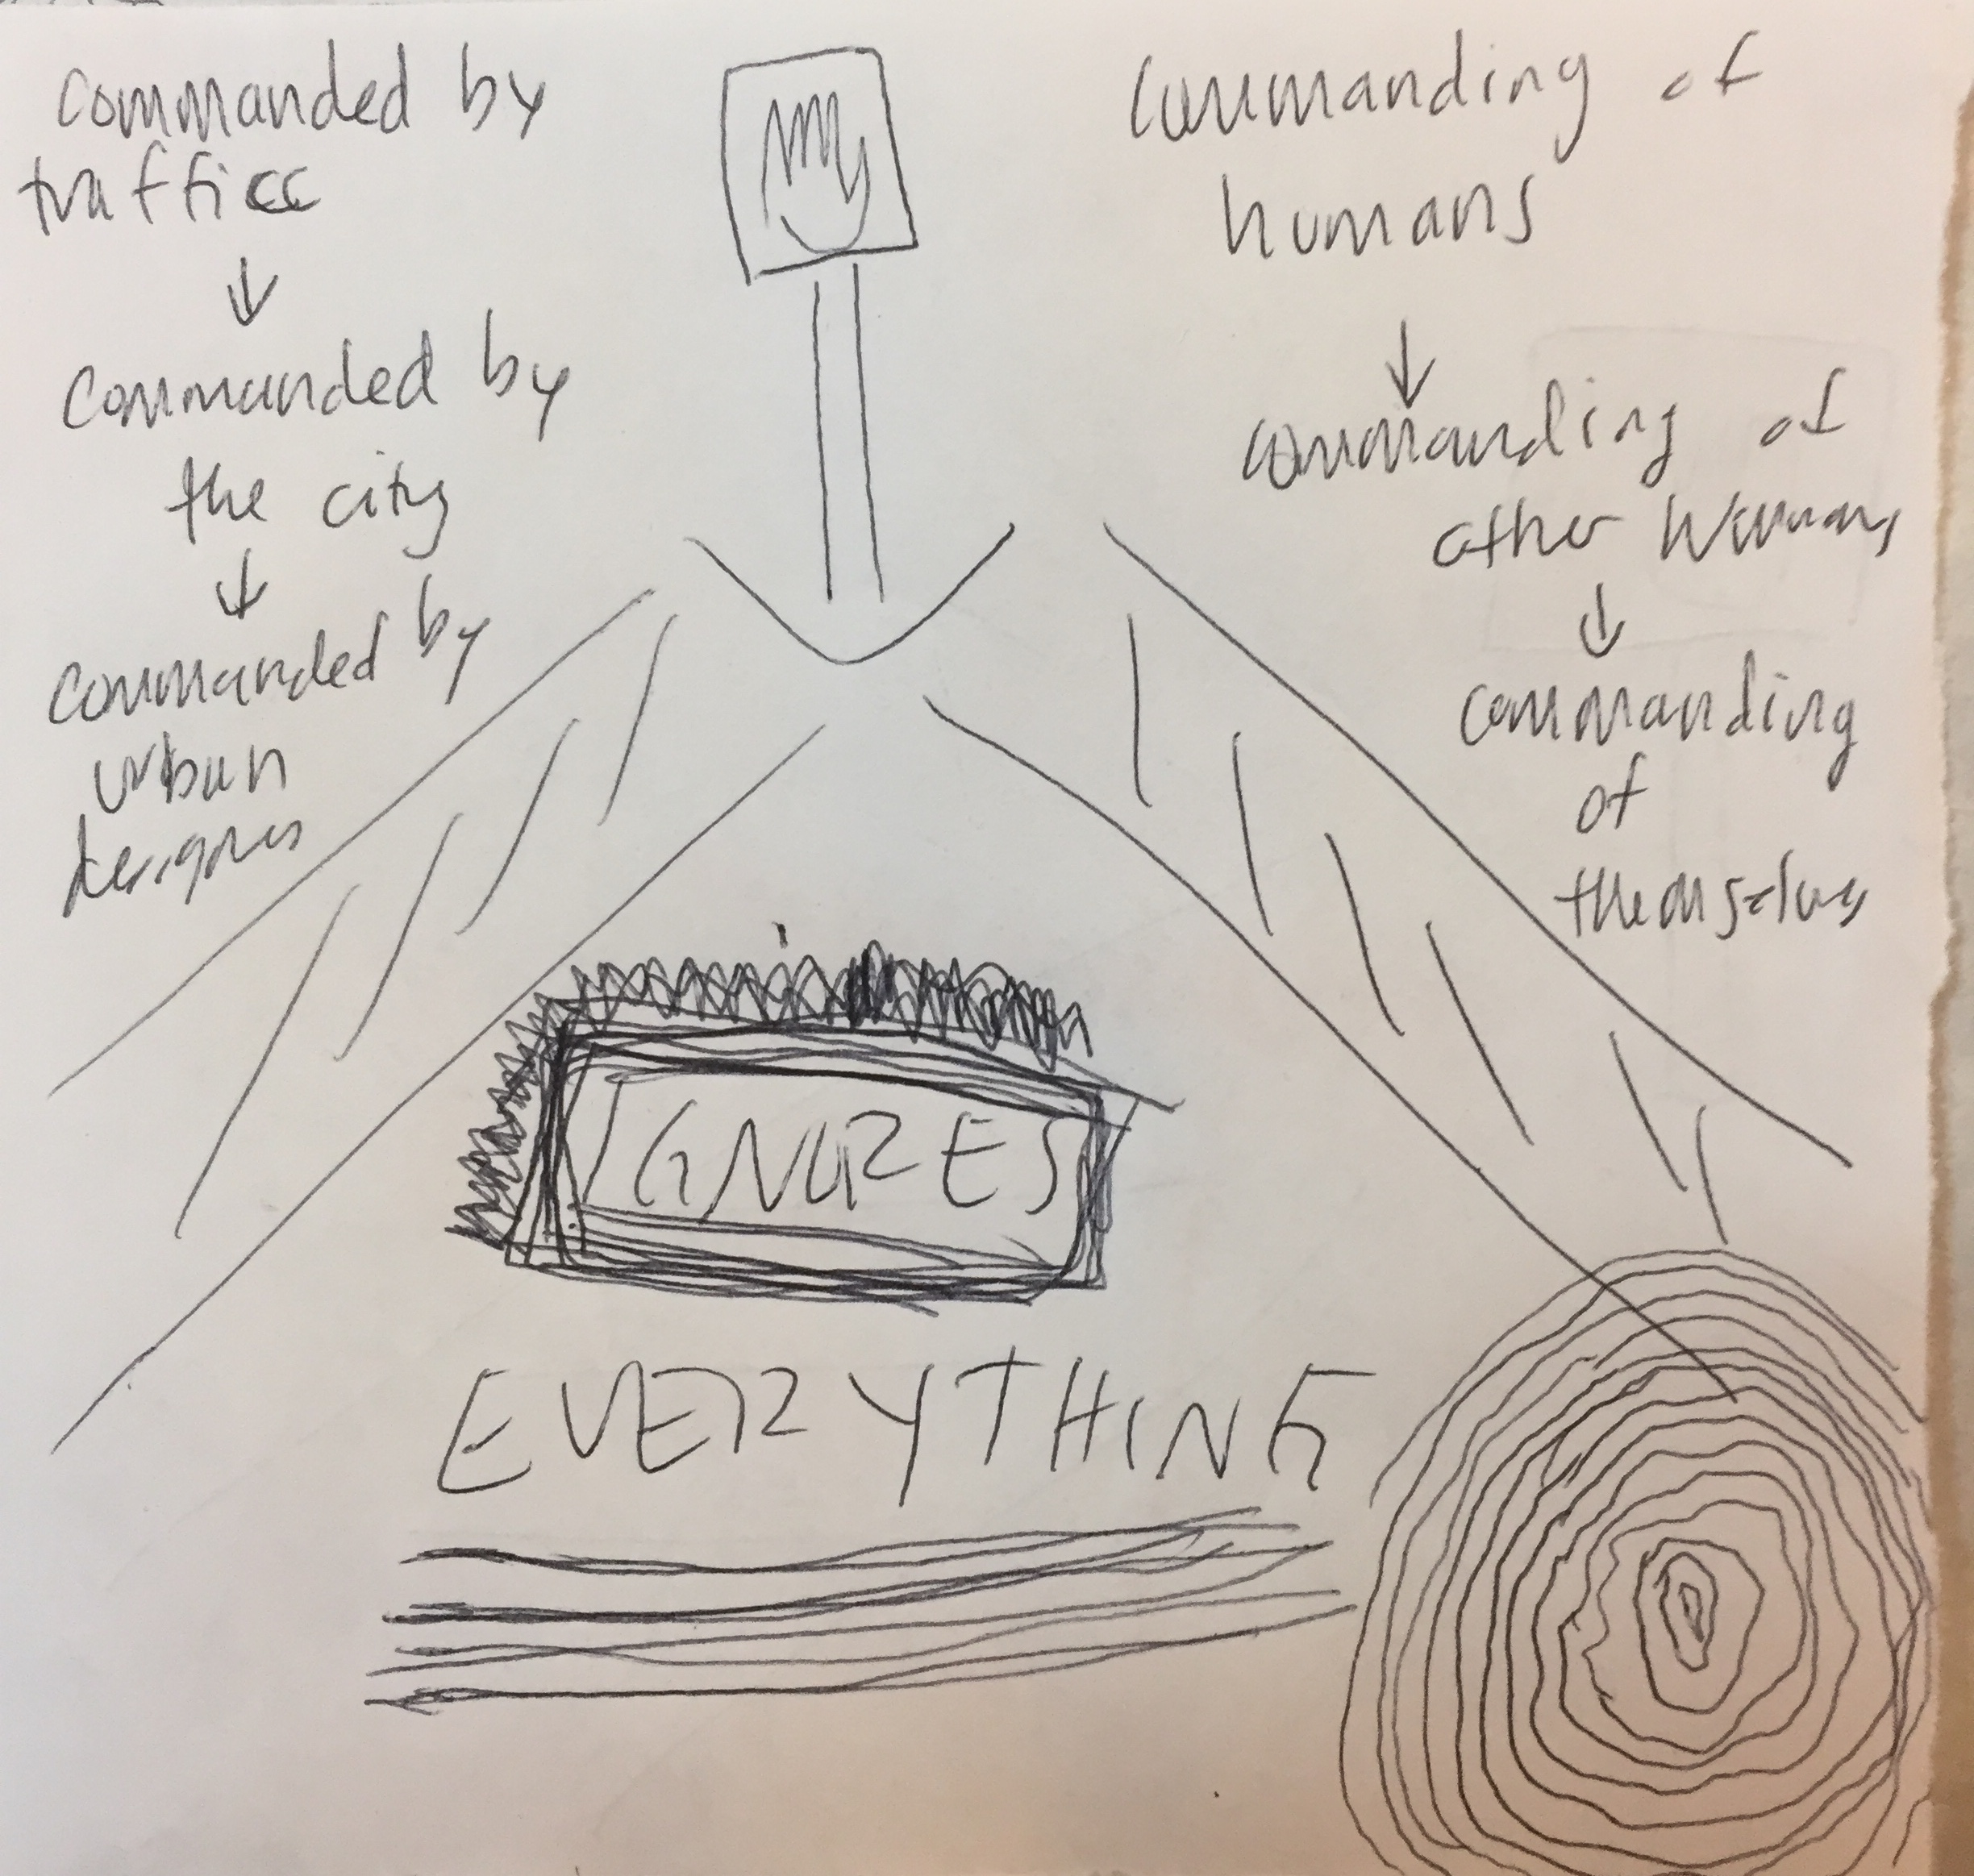

*\*\*Example of small table of care/maintenance from first run of workshop*

*Part II:   
Pair work & Guided discussion  
 25 min.*

**Pair work: (10 min)**

→ Split up into pairs & create small tables of maintenance/care

→ Reflect on associations there might be between your two elements: does one influence the the other ? How ?

→ Find yourselves on the Map of the Encounter of the Encounters & create edges between elements (nodes) if associations have been found.

**Presentation & Discussion:**

→ Share to group & discuss

→ If other associations arise

*\*\*What does it mean for a human body to experience a city? For whom are cities designed, and how does this shape experiences for others?*

*Part III:*

*What and Who is ‘the city’? & why is this an anti-drift?*

*10 min.*

*→ A brief context of Astor Place, what pedestrian plazas are and who/what is ‘the city’?*

[***DOT***](https://www1.nyc.gov/html/dot/html/home/home.shtml) ***,*** [***THE VILLAGE ALLIANCE***](https://greenwichvillage.nyc/) ***,*** [***CITY Government***](https://www1.nyc.gov/)

***→*** *Why is this an “anti-drift” ; how does this exercise insinuate that there is no way to ‘wander’ in a city without a prescribed agenda? How do we subvert this and take charge of these agendas? And why is it important to do so?*

***\*\*\*\*The results of this will live on a static web page that I will build prior that participants can refer back to.\*\*\*\*\****

*References:*

[***How to see infrastructure***](https://rhizome.org/editorial/2015/jul/2/how-see-infrastructure-guide-seven-billion-primate/)

[***Seeing Networks - Ingrid Burrington***](http://seeingnetworks.in/nyc/)

[**What does resilience mean ?**](https://thedistanceplanlexicon.org/RESILIENCE-RHETORIC)

[**Infrastructural Tourism**](https://placesjournal.org/article/infrastructural-tourism/)

Books that may be related:

*Underground* by David MaCauley

*The Life and Death of American Cities* by Jane Jacobs

*Ecology Without Nature* by Timothy Morton